



Louisiana State University
Industrial Training & Assessment Center

Energy, Waste, and Productivity Assistance for Industry
A U.S. Department of Energy Sponsored Program

Assessment Report

Report No.: LS2502
Location: Houma, LA
Principal Products: Industrial Valves
SIC Number: 3491
Visit Date: 09/23/2024

Dr. Jonathan Shi – Director | Asif Faisal Chowdhury – Student Lead
Dr. Chao Wang – Assistant Director | Ashley Davies– Safety/Equipment Lead
Ms. Chandler Hayes – Assistant Director | Selena Dang– Student Engineer
 | Tara Bui – Student Engineer
 | Maryam Soleymani – Student Engineer
 | Mahdi Bonyaniakbarabadi – Student Engineer

Louisiana State University - Industrial Training & Assessment Center (LSU-ITAC)
College of Engineering
3319 Patrick F. Taylor Hall, Baton Rouge, LA
Phone: (225) 578-8652
PREFACE

The work described in this report was performed by the Louisiana State University-Industrial Training & Assessment Center (LSU-ITAC) at the Louisiana State University under contract with the Office of Manufacturing and Energy Supply Chains (MESC) of the U.S. Department of Energy. The ITAC program is managed by the Center for Advanced Energy Systems, Rutgers University, Piscataway, NJ, under contract with the U.S. Department of Energy.

The objective of the ITAC program is to identify and evaluate opportunities for energy efficiency improvements through visits to industrial facilities. The evaluation process is based on the data gathered during a one-day site visit and is thereby affected in detail and completeness by limitations on time at the site. In cases where assessment recommendations (ARs) involving engineering design and capital investment are attractive to the company, it is recommended that the services of a consulting engineering firm be engaged (when in-house expertise is not available) to do detailed engineering design and to estimate implementation costs. Comments regarding this assessment report and information about plans to implement the ARs identified are solicited.

In this assessment, all students visited the facility and provided their technical assessment through field observation, and discussions with the facility personnel, and they also participated in developing the final assessment report. For this report, Asif Faisal Chowdhury was the Student Lead who led the facility visit and report writing, Ashlee Davies was the Safety/Equipment Lead, and Selena Dang, Tara Bui, Maryam Soleymani, and Mahdi Bonyaniakbarabadi were the Student Engineers who followed the student lead and faculty’s instructions.

DISCLAIMER

The contents of this report are offered as guidance. Rutgers University (the State University of New Jersey), Louisiana State University, and all technical sources referenced in the report do not (a) make any warranty (expressed or implied) with respect to the accuracy, completeness, or usefulness of the information contained in this report; (b) represent that the use of any information, apparatus, method, or process disclosed in this report will not infringe on privately owned rights; or (c) assume any liabilities with respect to the use of, or for damages resulting from the use of, any information, apparatus, method, or process disclosed in this report. This report does not reflect official views or policies of the abovementioned institutions. Mention of trade names or commercial products does not constitute endorsement or recommendation of use.

Table of Contents

1 EXECUTIVE SUMMARY 6
1.1 General Information 6
1.2 Annual Energy Usages and Costs 6
1.3 Carbon Footprint 6
1.4 Summary of Best Practices and Assessment Recommendations 7
2 GENERAL FACILITY BACKGROUND 9
2.1 Facility Description 9
2.2 Process Description 10
2.3 Historical Energy Usage 11
2.4 Major Energy Consuming Equipment and Devices 13
3 CURRENT BEST PRACTICES 14
3.1 Partial Implementation of LED Retrofits in Facility 15
3.2 External Lights are Placed on Photocells 15
3.3 Implementation of Cross Team collaboration 16
3.4 Partial Implementation of Electric Forklifts 16
4 ASSESSMENT RECOMMENDATIONS (ARS) 18
4.1 AR No. 1 – HVAC Tune-Up to Increase Energy Efficiency 18
4.2 AR No. 2 – Reduce the Discharge Pressure of the Compressed Air System 22
4.3 AR No. 3 – Install Occupancy Sensors 26
4.4 AR No. 4 – Eliminate Leaks in Compressed Air Lines 30
4.5 AR No. 5 – Utilize Higher Efficiency Lamps and/or Ballasts 34
5 THE INDUSTRIAL CONTROL SYSTEMS CYBERSECURITY ASSESSMENT 40

Table of Figures

Figure 2-1. The Satellite View of the Facility 9
Figure 2-2. The Production Process Flowchart 10
Figure 2-3. Monthly Electricity Usage 11
Figure 2-4. Monthly Electricity Usage 11
Figure 2-5. Monthly Demand Charge 12
Figure 2-6. Monthly Demand Usage 12
Figure 2-7. Monthly Natural Gas Cost 13
Figure 2-8. Monthly Natural Gas Usage 13
Figure 2-9. The Major Power Consumers 14
Figure 3-1. LED Retrofits in the Facility 15
Figure 3-2. External Light on Photocells 16
Figure 3-3. Benefits of Cross Training2 16
Figure 3-4. Benefits of Electrical Forklift 17
Figure 4-1. One of the HVAC Units 18
Figure 4-2. One of the Air Compressor’s Control 22
Figure 4-3. The Occupancy Sensor 28
Figure 4-4. Compressed Air Leaks Detected in the Facility. 30
Figure 4-5. The LED vs Fluorescent Lighting comparison. 34
Figure 4-6. Recommended LED Lighting Types 38

List of Tables

Table 1-1.The Facility Energy and Material Usage Summary 6
Table 1-2. The Carbon Footprint of the Facility 6
Table 1-3. The Assessment Recommendation Summary Table 8
Table 2-1. Operating Hours and Shift Schedule 9
Table 2-2. The Major Power Consuming Equipment 14
Table 4-1. The Savings Summary for AR No. 1 18
Table 4-2. The Summary of Old HVAC Units in the Center 18
Table 4-3. The Implementation Cost Summary for AR No. 1 21
Table 4-4. The Savings Summary for AR No. 2 22
Table 4-5. The Implementation Cost Summary for AR No. 2 25
Table 4-6. The Savings Summary for AR No. 3 26
Table 4-7. The Summary of Existing Lighting Equipment for Sensor Installation 26
Table 4-8. The Implementation Cost Summary for AR No. 3 29
Table 4-9. The Savings Summary for AR No. 4 30
Table 4-10. The Air Compressor Information 31
Table 4-11. The Implementation Cost Summary for AR No. 4 33
Table 4-12. The Savings Summary for AR No. 5 34
Table 4-13. The Summary of Existing Lighting Equipment in the Facility 35
Table 4-14. The Summary of Recommended Lighting Equipment in the Facility 35
Table 4-15. The Implementation Cost Summary for AR No. 5 39
Table ‎5-1. Industrial Control Systems Cybersecurity Assessment Details 40

EXECUTIVE SUMMARY
Report No.: LS2502

General Information

SIC. No.: 3491 | Annual Production: 6,200 units/yr
NAICS Code: 332911 | Annual Sales: $35,000,000/yr
Principal Product: Industrial Valves | Value per Finished Product: $5,645/unit
No. of Employees: 120 | Total Energy Usage: 11,962 MMBTU/yr
Total Facility Area: 211,185 ft² | Total Utility Cost: $340,614
Operating Hours: 5,616 hr/yr | No. of Assessment Recommendations: 5

Annual Energy Usages and Costs

Energy usage and the corresponding costs at the facility during the twelve-month period between June 2023 and July 2024 are summarized in Table 1-1:

Table 1-1.The Facility Energy and Material Usage Summary
Type | Usage | Cost | Unit Cost
Electrical Energy | 2,763,509 kWh/yr  (9,429 MMBTU/yr) | $308,828/yr | $0.112/kWh
Demand Charge | 2,483 kW/yr | $8,408/yr | $3.387/kW
Natural Gas | 2,325 MMBTU/yr | $12,911/yr | $5.554/MMBTU
Propane Gas | 208 MMBTU/yr | $10,467/yr | $50.322/MMBTU
Total Utility | 11,962 MMBTU/yr | $340,614/yr | -

Carbon Footprint

Based on the facility's energy consumption and regional averages (Entergy's Climate Scenario Analysis0F and Carbon Dioxide Emissions Coefficients1F) for carbon dioxide emissions associated with this energy release, the plant's current carbon footprint can be calculated with the results as shown in Table 1-2:

Table 1-2. The Carbon Footprint of the Facility
Electricity | 1,054 | Tons CO₂/yr
Natural Gas | 136 | Tons CO₂/yr
Propane Gas | 12 | Tons CO₂/yr
Total | 1,202 | Tons CO₂/yr

Summary of Best Practices and Assessment Recommendations

The assessment team has found four best practices and five areas for potential improvements at the facility. Detailed descriptions of the best practices are presented in Section 3 of this report. The four best practices observed are listed as follows:

- Partial Implementation of LED Retrofits in the Facility
- External Lights are Placed on Photocells
- Implementation of Cross Team Collaboration
- Partial Implementation of Electric Forklifts

The five Assessments Recommendations (ARs) together represent the total cost savings of $27,853/yr, which is 8.18% of the current total annual utility costs. The total implementation cost is estimated at $7,410, yielding an average payback of 0.27 years. If all ARs are implemented, these measures will result in an annual reduction of 92 tons/yr in carbon dioxide emissions, which is 7.65% of current emissions. Detailed analysis and savings calculations of the ARs are provided in Section 4 of this report. The ARs are summarized as follows with their key savings information as listed in Table 1-3:

AR No. 1 – HVAC Tune-Up to Increase Energy Efficiency
- Performing a tune-up of the HVAC system will optimize its performance and increase energy efficiency. This recommendation includes adjusting and calibrating system controls, cleaning components, and ensuring proper operation. The annual savings from this recommendation are estimated to be $8,06 with no implementation cost

AR No. 2 – Reduce the Discharge Pressure of the Compressed Air System
- Reducing the discharge pressure of the compressed air system will decrease the energy consumption of the air compressor while still maintaining adequate pressure for equipment operation. The annual savings from this recommendation are estimated to be $2,792 and an implementation cost of $10.

AR No. 3 – Install Occupancy Sensors
- Installing occupancy sensors in appropriate areas will automatically control lighting based on space occupancy, eliminating unnecessary lighting usage when spaces are vacant. The annual savings from this recommendation are estimated to be $6,307 with an implementation cost of $300.

AR No. 4 – Eliminate Leaks in Compressed Air Lines
- Eliminating leaks in the compressed air lines will reduce unnecessary waste of compressed air and reduce energy consumption. The savings from this recommendation are estimated to save $905 annually and $45 in implementation cost.

AR No. 5 –Utilize Higher Efficiency Lamps and/or Ballasts
- Upgrading to higher efficiency lamps and/or ballasts will significantly reduce electrical consumption while maintaining required lighting levels. The annual savings from this recommendation are estimated to be $9,783 with an implementation cost of $6,965 Upgrading to higher efficiency lamps and/or ballasts will significantly reduce electrical consumption while maintaining required lighting levels.

Table 1-3. The Assessment Recommendation Summary Table
AR No. | Category | Description | Electricity Savings (kWh/yr) | Energy Cost Savings ($/yr) | Demand Savings  (kW/yr) | Demand Cost Savings  ($/yr) | Total Cost Savings ($/yr) | CO₂ Reduction (Tons/yr) | Impl.  Cost ($) | Payback Period  (yrs)
1 | Building and Grounds | HVAC Tune-Up to Increase Energy Efficiency | 72,020 | 8,066 | 0 | 0 | 8,066 | 27 | 0 | 0
2 | Motor Systems | Reduce the Discharge Pressure of the Compressed Air System | 24,928 | 2,792 | 0 | 0 | 2,792 | 10 | 100 | 0.04
3 | Motor Systems | Install Occupancy Sensors | 56,313 | 6,307 | 0 | 0 | 6,307 | 21 | 300 | 0.05
4 | Combustion Systems | Eliminate Leaks in Compressed Air Lines | 8,083 | 905 | 0 | 0 | 905 | 3 | 45 | 0.05
5 | Motor Systems | Utilize Higher Efficiency Lamps and/or Ballasts | 82,050 | 9,190 | 175 | 593 | 9,783 | 31 | 6,965 | 0.71
 |  | TOTALS | 243,394 | 27,260 | 175 | 593 | 27,853 | 92 | 7,410 | 0.27

GENERAL FACILITY BACKGROUND

Facility Description

A satellite view of the 211,185 square feet facility is shown in Figure 2-1. The facility has a total of five buildings and they are used for Welding, Painting, and Inventory. The facility operates in two major shifts with an average of 24 hours/day, 4.5 days/week and 52 weeks/yr which total to 5,616 hrs/yr. The total number of employees is 120. The facility's operating hours and shifts are summarized in Table 2-1.

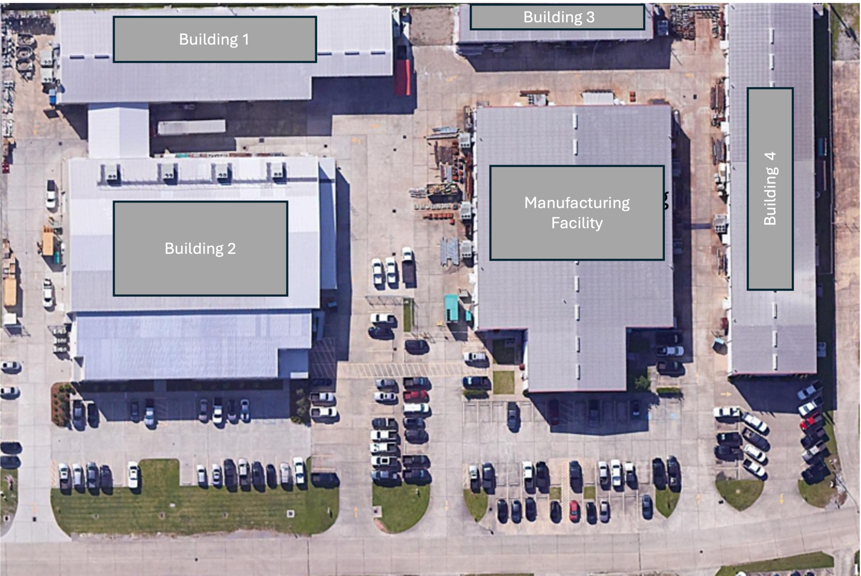
Figure 2-1. The Satellite View of the Facility

Table 2-1. Operating Hours and Shift Schedule
Shift Start – Shift End | Days/Week | Number of Employees
6:00 AM – 6:00 PM | 5 | 120
6:00 PM – 6:00 AM | 4 | 120

Process Description

The production process at the facility begins with the engineering and design of flow control products, including chokes, valves, and API flow line components. Raw materials, such as high-grade metals and alloys, are carefully selected and inspected for quality. These materials undergo precision machining using advanced CNC equipment to create individual components according to detailed specifications. The machined parts are then subjected to surface treatments and coatings to enhance corrosion resistance and durability. Next, the components are assembled into complete products using specialized tools and equipment. This assembly process is carried out by skilled technicians who follow strict quality control procedures. The assembled products then undergo rigorous testing to ensure they meet or exceed API Specification 6A requirements. This test includes pressure tests, functional checks, and material verification. Following successful testing, the products are cleaned, inspected, and prepared for finishing. This may involve additional surface treatments, painting, or the application of protective coatings. Quality control inspections are performed at each stage of the process to maintain high standards. The finished products are then packaged in protective containers, labeled, and stored in the facility's inventory management system. Throughout the entire process, the facility’s ERP system tracks and monitors production in real-time, ensuring full traceability of materials and components. The facility operates 24/7 to maintain efficiency and meet customer demands promptly. Finally, the completed flow control products are prepared for shipment to customers or transferred to other facilities for further integration into larger systems or valve manifold packages. The process flow is shown in Figure 2-2.

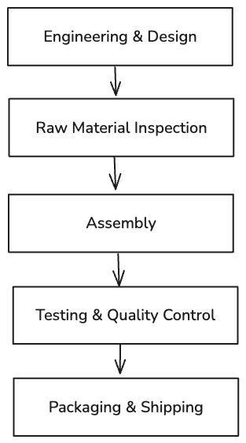
Figure 2-2. The Production Process Flowchart

Historical Energy Usage

The client provided monthly electricity costs and electricity usage of the facility for one year from Aug 2023 to July 2024, as shown in Figure 2-3 and Figure 2-4, respectively. The electricity rate is estimated at 11.2 cents per kWh. The following findings can be observed from the figures on electricity usage and information from the site visit:
- The electricity cost shows notable fluctuations throughout the year, with peaks occurring in August 2023
- A significant dip in costs is observed during October-November 2023
- There is a gradual increase in electricity costs from February 2024 through July 2024

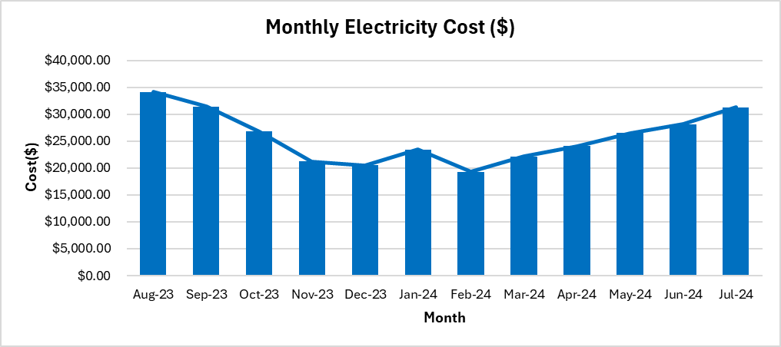
Figure 2-3. Monthly Electricity Usage

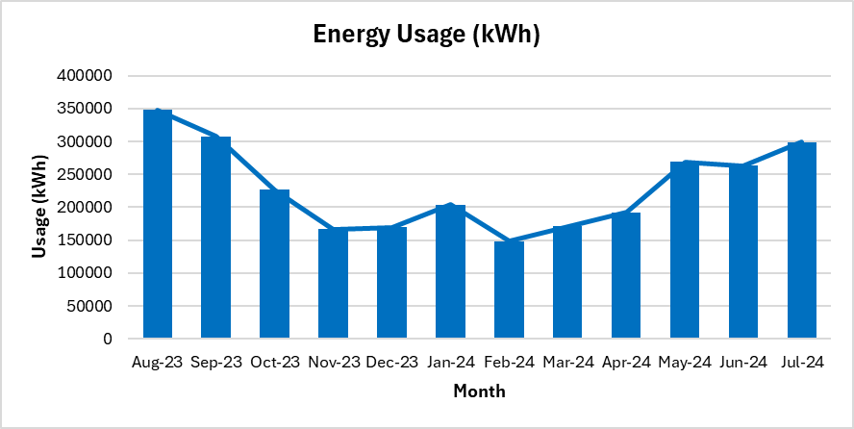
Figure 2-4. Monthly Electricity Usage

Figure ‎2-4 shows the following observations:

- The peak consumption occurred during August-September 2023, reaching approximately 350,000 kWh, which likely indicates peak production periods at the facility.
- The lowest consumption was recorded during January 2024-February 2024, suggesting reduced facility operations or seasonal production variations.
The facility’s monthly demand costs are plotted in Figure 2-5. Figure 2-6 demonstrates the monthly demand usage in kW. Based on our analysis, the demand charge is estimated to be $3.387 per kW. The highest demand cost and the peak energy usage occurred from August to September 2023.

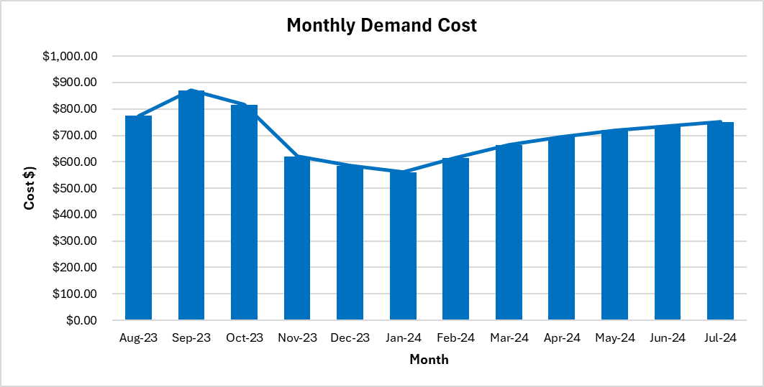
Figure 2-5. Monthly Demand Charge

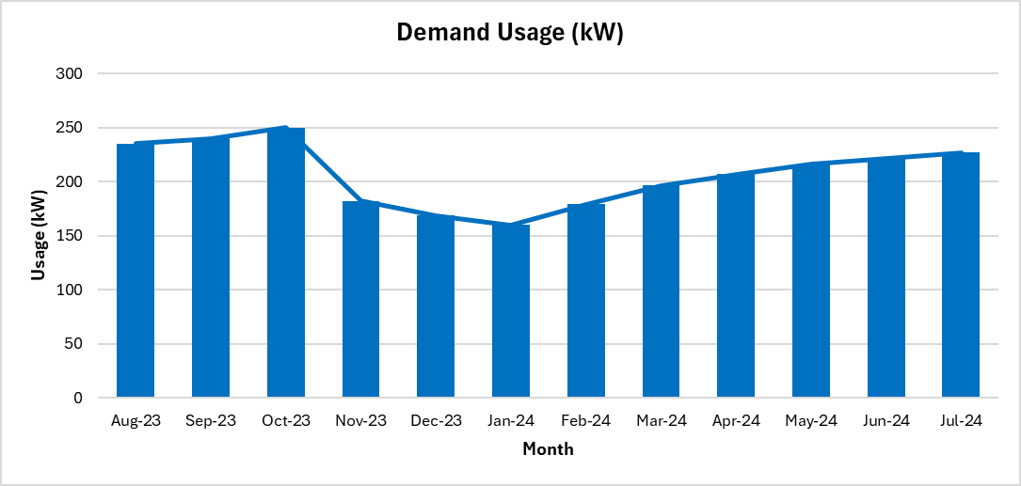
Figure 2-6. Monthly Demand Usage
The facility’s natural gas cost and usage are plotted in Figure 2-7 and Figure 2-8, respectively. Based on the previous 12 months natural gas bills, the facility procures natural gas an average rate of $5.554/MMBTU. The peak usage is in spring, and this corresponds with the natural gas cost.

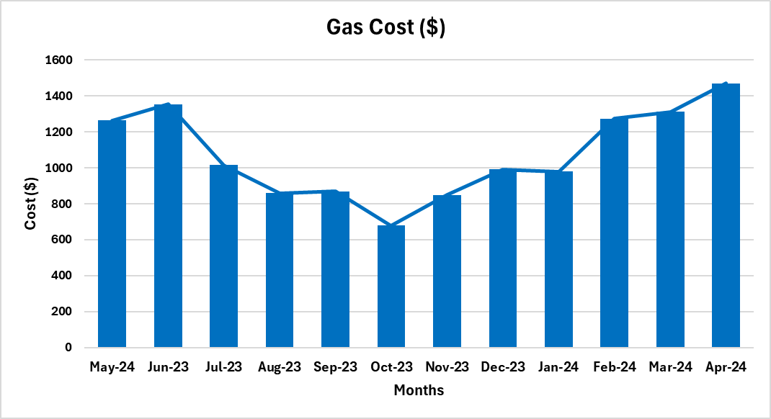
Figure 2-7. Monthly Natural Gas Cost

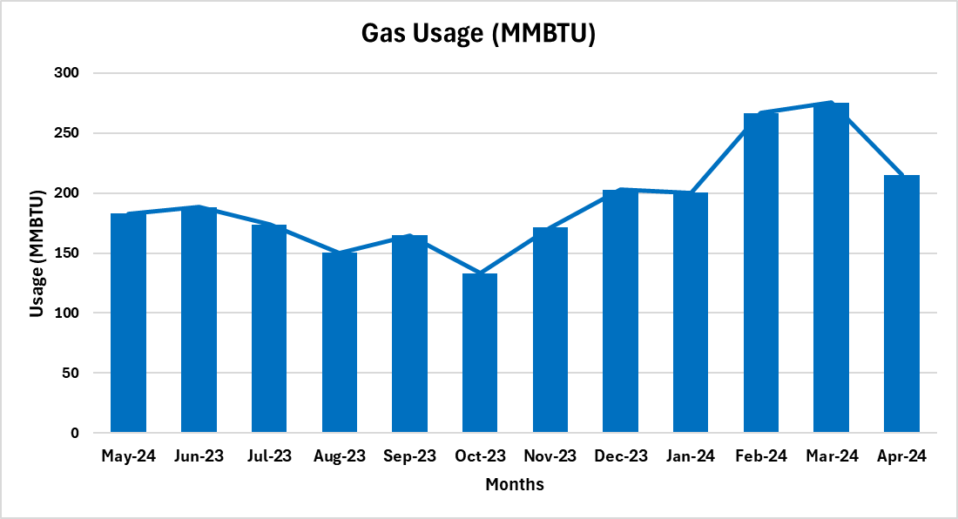
Figure 2-8. Monthly Natural Gas Usage

Major Energy Consuming Equipment and Devices

A list of major equipment and devices is provided in Potential major consumer omitted from the list are the chillers as specification details were not available. Table 2-2 and Figure 2-9 shows how much power is used by each piece of equipment in the facility. This figure indicates that the Expander is the primary power consumer in the facility, accounting for 29% of the total power. Potential major consumer omitted from the list are the chillers as specification details were not available.
Table 2-2. The Major Power Consuming Equipment
Energy Application | Power (hp) | Quantity | Total Power (hp) | Percentage
Welding Machines | 93 | 5 | 577 | 61%
Welding Machines | 56 | 2 | 577 | 61%
Chillers | 25 | 7 | 175 | 18%
Air Compressor | 50 | 4 | 200 | 21%
Total |  | 18 | 952 | 100%

Figure 2-9. The Major Power Consumers

CURRENT BEST PRACTICES

During the visit and discussion with the facility managers, the LSU-ITAC team found that the facility management team currently employs a few good practices, which are briefly described below.

Partial Implementation of LED Retrofits in Facility
The LSU-ITAC team observed that in some areas of the facility, LED lighting fixtures had been installed in place of the previous traditional lighting fixtures (see Figure 3-1). This is one of the best practices, as LED consumes less energy to produce the same level of lumen output. Also, LED lighting sources emit less heat when operating compared to traditional lighting fixtures. This will help improve the overall building energy efficiency

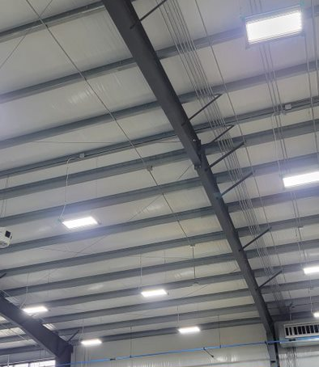
Figure 3-1. LED Retrofits in the Facility

External Lights are Placed on Photocells
The facility placed their external lights on photocells so that the lights only turn on when there is no adequate daylight. This practice helps to utilize artificial lighting only when necessary, which allows savings in cost and electrical consumption. The external lights on photocells are shown in Figure 3-2.

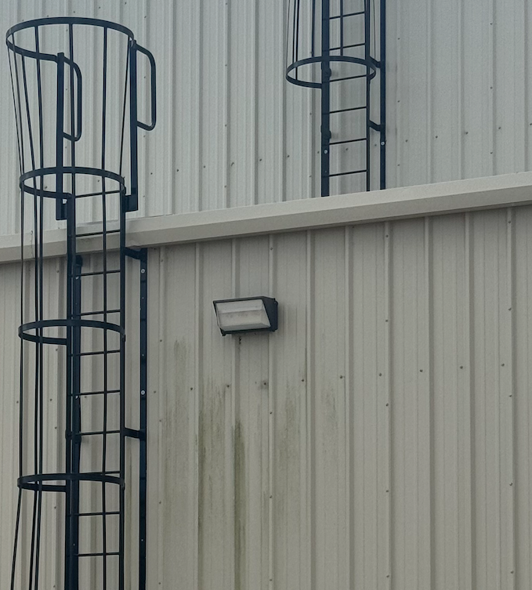
Figure 3-2. External Light on Photocells

Implementation of Cross Team collaboration
The facility cross trains their employees to ensure workers have knowledge of different aspects of the process. (see Figure 3-3). This enhances employee flexibility and adaptability, enabling team members to perform various tasks and cover for each other during absences, which improves operational efficiency.

Figure 3-3. Benefits of Cross Training2

Partial Implementation of Electric Forklifts
The LSU-ITAC team observed that in some areas of the facility, electric forklifts had been deployed to replace traditional propane-powered units. (See Figure 3-4)This is one of the best practices, as electric forklifts consume less energy and have lower operating costs compared to fossil fuel alternatives. Also, electric forklifts produce zero direct emissions and generate less noise during operation compared to conventional fuel-powered units. This will help improve both the facility's environmental impact and workplace conditions.

.

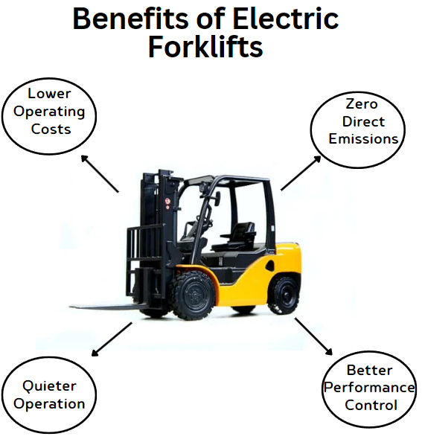
Figure 3-4. Benefits of Electrical Forklift

ASSESSMENT RECOMMENDATIONS (ARS)
This section provides detailed calculations and analyses for the assessment recommendations (ARs).

AR No. 1 – HVAC Tune-Up to Increase Energy Efficiency
(ARC Code 2.7211)
Table 4-1. The Savings Summary for AR No. 1
Energy Savings (kWh/yr) | Energy Cost Savings ($/yr) | Total Cost Savings ($/yr) | CO₂ Reduction (Tons/yr) | Imp. Cost ($) | Payback Period  (yr)
72,020 | 8,066 | 8,066 | 27 | 0 | 0.00

Observation and Analysis
During the assessment tour, the LSU-ITAC team found that the facility makes use of air-cooled condenser (a total 175 tons) in cooling the building. The facility management mentioned not having a regular HVAC maintenance program for the units at the facility. This could lead to reduced efficiency and higher energy consumption from the HVAC units (see Figure 4-1). A tune-up and maintenance schedule helps to ensure proper cooling of the conditioned space and meets the desired temperature requirement. We obtained the energy efficiency rating (EER) from the nameplates of the units, which conform with ASHRAE Building Efficiency Standards. The summary of the old HVAC units is shown in Table 4-2.

Table 4-2. The Summary of Old HVAC Units in the Center
HVAC Unit Tonnage | Quantity | Total Tonnage | EER
25-ton | 7 | 175-ton | 10.6

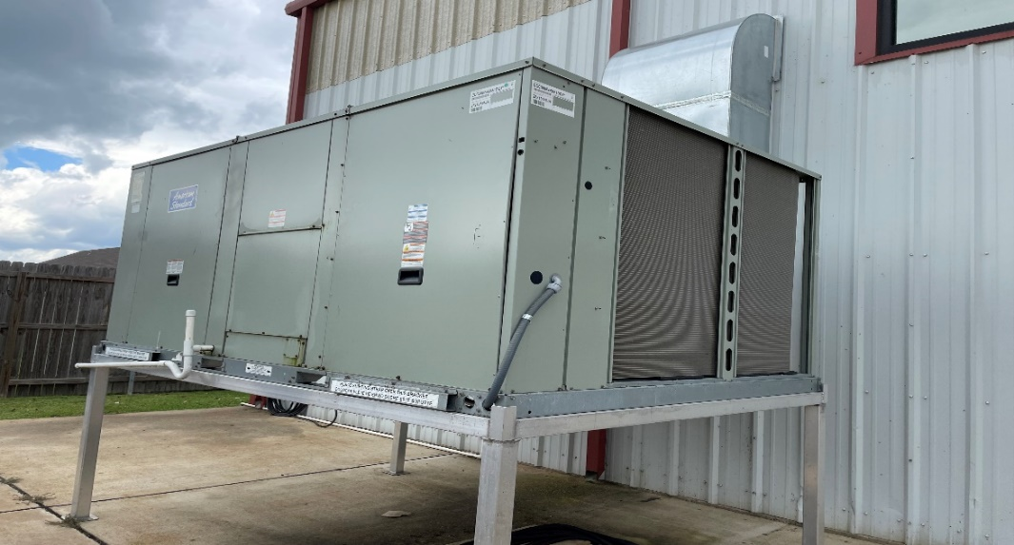
Figure 4-1. One of the HVAC Units

Recommendation
LSU-ITAC recommends performing an HVAC tune-up which involves checking, adjusting, and resetting the equipment to factory conditions such that it operates closer to the performance level of a new unit. A typical AC-tune-up checklist may include inspecting and cleaning the condenser, evaporator, and blower, inspecting the refrigerant level, calibrating the thermostat, tightening all electrical connections, changing air filters, etc. This recommendation will increase efficiency and improve comfort, reducing energy consumption and costs.

Calculations
The electrical savings calculation is estimated from the energy efficiency ratio (EERpre) before performing the AC tune-up. The EERpre can be determined by the efficiency loss percentage (EL) calculated from the refrigerant charge level. Due to the time limitation during the assessment, the team was not able to calculate the efficiency loss, but the incorrect refrigerant level has been proven to reduce efficiency by close to 20%, leaking ducts reduce efficiency by 20%, and unclean blower component can reduce efficiency by 15% which limits the system airflow. Hence, we conservatively estimate that the efficiency reduction due to improper maintenance is 15% for the calculations. Recalling that the current cooling hours at the building type is 2,060 hrs/yr as estimated for Louisiana by the New Orleans Energy Smart Technical Reference Manual. Thus, we estimate the EERpre and electrical energy savings using the formula referenced in the technical manual.

Calculate the Current Efficiency of HVAC Units
EERpre = (1 − EL) × EERpost
= (1 – 0.15) × 10.6 Btu/hr/Watts
= 9.01 Btu/hr/Watts
where,
EERpre = Current Average Energy Efficiency Ratio.
EL = Efficiency Loss
EERpost = Average Energy Efficiency Derived from Manufacturer's label.

Electrical Energy Savings
The electrical energy savings are calculated using the formula below:

ER = RC × B × ECH × (1/ EER_{pre} – 1/ EER_{post}) × CF
= 175-ton × 12,000 Btu/hr/ton × 2,060 hrs/yr × (1/9.01 – 1/10.6) W/Btu/hr × 0.001kW/W
= 72,020 kWh/yr
where,
ER = Energy Reduction, kWh/yr
RC = Total Rated Capacity of the HVAC units, tons
B = Conversion Constant, Btu/hr/ton
ECH = Equivalent Full-Load Cooling Hours, hrs/yr
EERpre = Current Average Energy Efficiency Ratio.
EERpost = Average Energy Efficiency Derived from Manufacturer's label.
CF = Conversion Factor, kW/W

Electrical Energy Cost Savings
The total energy cost can be calculated using:
ECS = ER × UR
= 72,020 kWh/yr × $0.112/kWh
= $8,066/yr,
where
ECS = Total Energy Cost Savings, $/yr
ER = Energy Reduction, kWh/yr
UR = Average Electrical Energy Usage Rate = $0.112/kWh

Total Cost Savings
In this case, the total cost savings are the electrical energy cost savings:
TCS = ECS
= $8,066/yr,
where
TCS = Total Cost Savings, $/yr
ECS = Total Electrical Energy Cost Savings, $/yr

Carbon Dioxide Reduction
Due to the reduced electrical usage, there will also be lower carbon dioxide emissions from the electric power generation. These reductions can be calculated using:
CO₂ = ER × K₁ × K₂
= 72,020 kWh/yr × (0.763 lb. CO₂ / kWh) × 1 Ton/2,000lb
= 27 Tons/yr,
where
CO₂ = Amount of Carbon Dioxide Reduced, Tons CO₂/yr
ER = Electrical Energy Reduction, kWh/yr
K₁ = Amount of CO₂ Produced per kWh = 0.763 lb. CO₂/kWh
K₂ = Conversion Factor = 1 ton/2,000 lbs

Implementation Cost
Implementation will involve the labor cost to tune up all the HVAC units. It is estimated that it takes two hours of labor for each HVAC unit's tune-up, and the hourly cost is about $100/hr. For a total of 7 HVAC units, the estimated labor cost will be $700. However, Entergy Solution provides a customized incentive for AC tune-up which is $65/ton. The implementation cost is shown in Table 4-3.
Table 4-3. The Implementation Cost Summary for AR No. 1
Cost Types | Quantity | Unit Cost | Cost ($)
AC-Tune Up | 7 units | $200/unit | 1,400
Incentive | 175 | $65/ton | -11,375
Total Implementation Cost |  |  | 0

Payback Period
PP = IC/TCS
= $0 / ($8,066/yr)
= 0.00 yrs,
where
PP = Payback Period, yrs
IC = Implementation Cost, $
TCS = Total Cost Savings, $/yr

AR No. 2 – Reduce the Discharge Pressure of the Compressed Air System
(ARC Code 2.4231)

Table 4-4. The Savings Summary for AR No. 2
Energy Savings (kWh/yr) | Energy Cost Savings ($/yr) | Total Cost Savings ($/yr) | CO₂ Reduction (Tons/yr) | Imp. Cost  ($) | Payback Period  (yrs)
24,928 | 2,792 | 2,792 | 10 | 100 | 0.04

Observation and Analysis
During the on-site assessment, LSU-ITAC observed that the facility might be keeping a higher air pressure than required. The three (3) air compressors of 50 HP were operating at about 120 psig while the facility personnel mentioned that a reduction no greater than 5 PSIG could be tested. The image of the air compressor setpoint is provided in Figure 4-2.

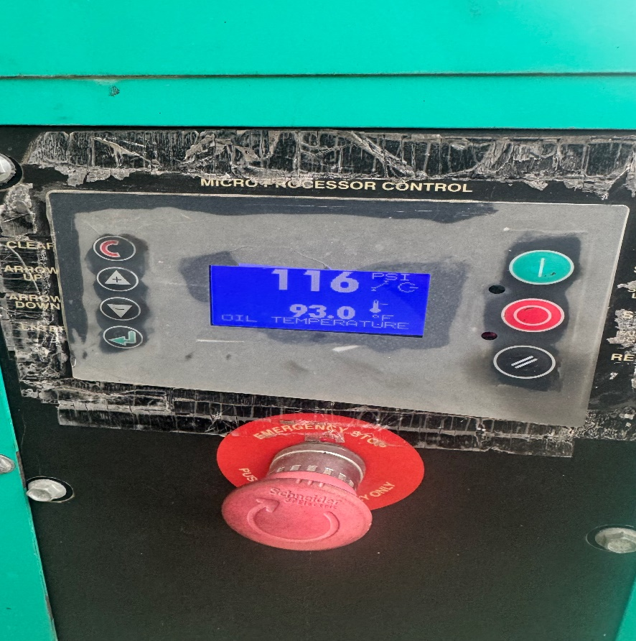
Figure 4-2. One of the Air Compressor’s Control

Recommendation
It is recommended that the facility reduces the discharge pressure of the system and conduct an air study to understand better why the pressure difference exists and to check if pressure reduction in the compressed air system is possible with all equipment running properly. The discharge air pressure, however, must be slowly decreased to avoid any unexpected problems. It can be achieved by reducing the air pressure by an increment of 1-2 PSIG, checking for the proper function of equipment each time. While the reduction to a certain psi is recommended, any pressure reduction will result in energy cost savings.
Calculations
Three 50 HP air compressors are considered for discharge pressure reductions. The average discharge pressure of the air compressors in the facility was 120 psig. The facility may have to maintain the pressure of 115 psig at the point of end use since a well-designed compressed air system has less than a 10% pressure difference between the air compressor and the point of end-use. Among various cases, we are considering a 5 psig reduction: 5 psig by assuming the pressure level of 115 psig at the point of end use. We conservatively choose a 5 psig reduction to avoid the pressure drop below the minimum requirement when the demand is the maximum. The calculation is shown below for the air compressors with a 5-psig reduction.

Current Energy Usage
The amount of current annual energy usage (EU_{C}) of the air compressor can be calculated using the following equation:
EU_{C} = $\frac{HP}{η }×C_{kW,hp}×Hrs× N$
= $\frac{(50 HP)}{0.941}$ $×$ 0.7459 $×$ 3,931$×$ 4
= 623,195 kWh/yr,
where
EU_{C} = Current Annual Energy Usage of the Air Compressor
HP = Compressor Horsepower, HP
ɳ = Efficiency of Compressor Motor = 0.941
C_{kW,hp} = Conversion Constant = 0.7459 kW/hp
Hrs = Annual Production Hours = 108 hrs/week ×52weeks/yr$×$ L
= 5,616 hrs/yr $×$ 0.7 = 3,931hrs/yr
L = Load Factor = 0.7
N = Number of Air Compressors = 4

Recommended Energy Use
The energy consumption of the air compressor decreases by approximately 1.6 to 2 percent with a 2 psi reduction in the discharge pressure of the air compressor. Thus, for every 1 psi pressure reduction, the energy savings will be (1.6 / 2) percent = 0.8 percent, which equals 0.008. The amount of annual energy consumption with pressure reduction can be calculated using the following equation:
EU_{R} = EU_{C} $×\left(1-S\right)$
= EU_{C} $×\left(1-0.008×∆P\right)$
= 623,195kWh/yr $×$ (1 – 0.008 $×$ 5)
= 598,267 kWh/yr,
where
EU_{R} = Recommended Annual Energy Usage
EU_{C} = Total Current Annual Energy Usage, kWh/yr
S = Power Reduction
$∆P$ = Pressure Reduction, 5 PSIG

Electrical Energy Savings
Using the total current and recommended energy usage for the air compressor, we can calculate the total annual energy savings for the pressure reduction in the following equation:
ER = EU_{C} – EU_{R}
= 623,195 kWh/yr –598,267 kWh/yr
= 24,928 kWh/yr,
where
ER = Energy Reduction
EU_{C} = Total Current Annual Energy Usage, kWh/yr
EU_{R} = Proposed Annual Energy Usage, kWh/yr

Electrical Energy Cost Savings
Based on the average electricity usage for the facility, we can calculate the total annual energy cost savings in the following equation:
ECS = ER $×$ UR
= 24,928 kWh/yr $×$ $0.112/kWh
= $2,792/yr,
where
ECS = Total Energy Cost Savings, $/yr
ER = Energy Reduction, kWh/yr
UR = Average Electrical Energy Usage Rate = $0.112/kWh

Total Cost Savings
In this case, the total cost savings are the same as energy cost savings, and can be calculated using:
TCS = ECS
= $2,792/yr,
where
TCS = Total Cost Savings, $/yr
ECS = Total Energy Cost Savings, $/yr

Carbon Dioxide Reduction
Due to the reduced electrical usage, there will also be lower carbon dioxide emissions in the electric power generation. These reductions can be calculated using:
CO₂ = ER $×$ K₁ $×$ K₂
= 24,928 kWh/yr $×$ (0.763 lb. CO₂ / kWh) $×$ 1 Ton/2,000lb
= 10 Tons/yr,
where
CO₂ = Amount of Carbon Dioxide Reduced, Tons CO₂/yr
ER = Energy Reduction, kWh/yr
K₁ = Amount of CO₂ Produced per kWh = 0.763 lb. CO₂/kWh
K₂ = Conversion Factor = 1Ton/2,000lb

Implementation Cost
Implementation will involve a worker reducing the pressure set points and checking for proper equipment function. For the air compressors, it will take approximately one hour for one worker. No installation of any material is required, and therefore the material cost is $0. Thus, the total cost of reducing the discharge pressure is estimated to be $75, as shown in Table 4-5.

Table 4-5. The Implementation Cost Summary for AR No. 2
Item | Cost ($)
Labor (One Worker at $25/hr for Four hours for 4 Compressors) | 100
Material | 0
Total Implementation Cost | 100

Payback Period
PP = IC / TCS
= $100 / ($2,792/yr)
= 0.04 yrs,
where
PP = Payback Period, yrs
IC = Implementation Cost, $
TCS = Total Cost Savings, $/yr

AR No. 3 – Install Occupancy Sensors
(ARC Code 2.7135)
Table 4-6. The Savings Summary for AR No. 3
Energy Savings (kWh/yr) | Energy Cost Savings ($/yr) | Total Cost Savings ($/yr) | CO₂ Reduction (Tons/yr) | Imp. Cost ($) | Payback Period  (yr)
56,313 | 6,307 | 6,307 | 21 | 300 | 0.05

Observation and Analysis
During the assessment tour, the LSU-ITAC team found that the lights in the warehouse, storage area, quality control, IMA and office in production were kept on even when the spaces were not occupied. Therefore, unnecessary electrical energy consumption could be prevented by turning off all lights when not in use.

Recommendation
LSU-ITAC recommends installing occupancy sensors in the specified locations to control the lighting to be dimmed down or turned off when the space is unoccupied. Specifically, for the production areas where it is necessary to have some illumination, some of the lights should always be kept on or dimmed to an acceptable level.

Calculations
It was observed that some of the production areas and storage areas had fluorescent lighting fixtures. In total, the number and power ratings of all fluorescent lighting fixtures are summarized in Table 4-7. Based on the information provided by the facility personnel, we conservatively estimated that each light could be turned off for about 30% of the time once the sensors are installed.

Table 4-7. The Summary of Existing Lighting Equipment for Sensor Installation
Location | Type | Rated Power (W) | Number Lights | Total Power (W)
Welding Shop | F32T8 | 32 | 245 | 7,840
Computer Machine Shop | F32T8 | 32 | 280 | 8,960
Paint Room | F32T8 | 32 | 340 | 10,880
Inventory Room | F32T8 | 32 | 180 | 5,740
Total Power (W) |  |  |  | 33,420

Current Energy Usage
The amount of current annual energy usage can be calculated using the following equation:
EU_{C} = W × CF × LH
= 33,420 W × 0.001 kW/W × 5,616 hrs/yr
= 187,687 kWh/yr,
where
EU_{C} = Current Annual Energy Usage, kWh/yr
W = Total Wattage of Lights
CF = Conversion Factor (kW/W) = 0.001 kW/W
LH = Current Lighting Hours = 108 hrs/week ×52weeks/yr = 5,616 hrs/yr
Proposed Energy Usage
After the facility installs the occupancy sensors, the annual electricity usage can be calculated as follows:
EU_{P} = W × CF × POH
= 33,420 W × 0.001 kW/W × 3,931 hrs/yr
= 131,374 kWh/yr,
where
EU_{P} = Proposed Annual Energy Usage, kWh/yr
W = Total Wattage of Lights
CF = Conversion Factor (kW/W) = 0.001
POH = Proposed Annual Operation Hours = 108 hrs/week ×52weeks/yr × 0.7 = 3931 hrs/yr

Electrical Energy Savings
The total amount of electrical energy savings for this implementation can be calculated as:
ER = EU_{C} – EU_{P}
= 187,687 kWh/yr –131,374 kWh/yr
= 56,313 kWh/yr,
where
ER = Energy Reduction, kWh/yr
EU_{C} = Total Current Annual Energy Usage, kWh/yr
EU_{P} = Proposed Annual Energy Usage, kWh/yr

Electrical Energy Cost Savings
The total energy cost savings after the facility installs the occupancy sensors can be calculated using:
ECS = ER × UR
= 56,313 kWh/yr × $0.112/kWh
= $6,307/yr,
where
ECS = Total Energy Cost Savings, $/yr
ER = Energy Reduction, kWh/yr
UR = Average Electrical Energy Usage Rate = $0.112/kWh

Total Cost Savings
In this case, the total cost savings are the electrical energy cost savings:
TCS = ECS
= $6,307/yr,
where
TCS = Total Cost Savings
ECS = Total Electrical Energy Cost Savings, $/yr

Carbon Dioxide Reduction
Due to the reduced electrical usage, there will also be lower carbon dioxide emissions at the electric power generation. These reductions can be calculated using:
CO₂ = ER × K₁ × K₂
= 56,313 kWh/yr × (0.763 lb. CO₂ / kWh) × 1 Ton/2,000lb
= 21 Tons/yr,
where
CO₂ = Amount of Carbon Dioxide Reduced, Tons CO₂/yr
ER = Electrical Energy Reduction, kWh/yr
K₁ = Amount of CO₂ Produced per kWh = 0.763 lb. CO₂/kWh
K₂ = Conversion Factor = 1 ton/2,000 lbs

Implementation Cost
Implementation will involve labor and occupancy sensor costs (see Figure 4-2). It is assumed that the labor cost is $25/hr, and the time needed for installation is one hour per occupancy sensor. It is estimated that the facility will need 1 occupancy sensor for each one for the specified areas in the office and 2 sensors for each of the production areas. Hence a total of 11 occupancy sensors are recommended.

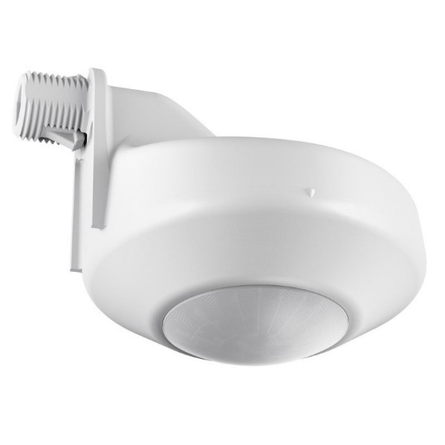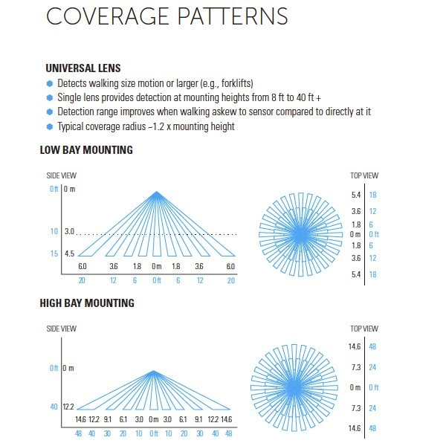

Figure 4-3. The Occupancy Sensor

Also, Entergy has a rebate program available in occupancy sensor installation. According to the prescriptive incentive rates requirement, the facility qualifies as a large commercial entity since its monthly peak demand exceeds 100 kW. The incentive rate is $0.11/W of light covered by sensors. Entergy only gives incentives on whichever is lower among material cost and electrical energy cost savings. The total implementation cost can be estimated by:
IC = (OC × ON – IO × W) + LR × LT
= ($55 × 12 – $0.11/W × 33,420 W) + $25/hour × 12 hours
= $0 (material) + $300 (labor)
= $300
where
IC = Implementation Cost, $
OC = Cost per Occupancy Sensor,, = $55
ON = Number of Occupancy Sensors Needed
IO = Incentive Rate for Occupancy Sensor Installation, $0.11/W
W = Collective Wattage for Occupancy Sensor Installment, W
LR = Labor Rate, $/hour
LT = Labor Time per Occupancy Sensor Installation, hour

Since the incentive cannot be higher than the material cost, the material cost would be zero as the incentive will cover it. The implementation cost of this recommendation is summed up Table 4-8.

Table 4-8. The Implementation Cost Summary for AR No. 3
Item | Quantity | Unit Cost | Incentives | Cost ($)
Material (Occupancy Sensor), , | 12 | $55/unit | $0.11/W | 0
Labor | 12 hrs | $25/hr | - | 300
Total Implementation Cost |  |  |  | 300

Payback Period
PP = IC/TCS
= $300 / ($6,307/yr)
= 0.05 yrs,
where
PP = Payback Period, yrs
IC = Implementation Cost, $
TCS = Total Cost Savings, $/yr

AR No. 4 – Eliminate Leaks in Compressed Air Lines
(ARC Code 2.4236)

Table 4-9. The Savings Summary for AR No. 4
Energy Savings (kWh/yr) | Energy Cost Savings ($/yr) | Total Cost Savings ($/yr) | CO₂ Reduction (Tons/yr) | Imp. Cost  ($) | Payback Period  (yrs)
8,083 | 905 | 905 | 3 | 45 | 0.05

Observation and Analysis
In the facility, the LSU-ITAC team observed an air leak in the compressed air distribution system. It was audibly heard near the leak location, and upon closer inspection with an ultrasonic detector, the intensity of the leak was measured at 85 dB. The air compressor is shown in Figure 4-4.

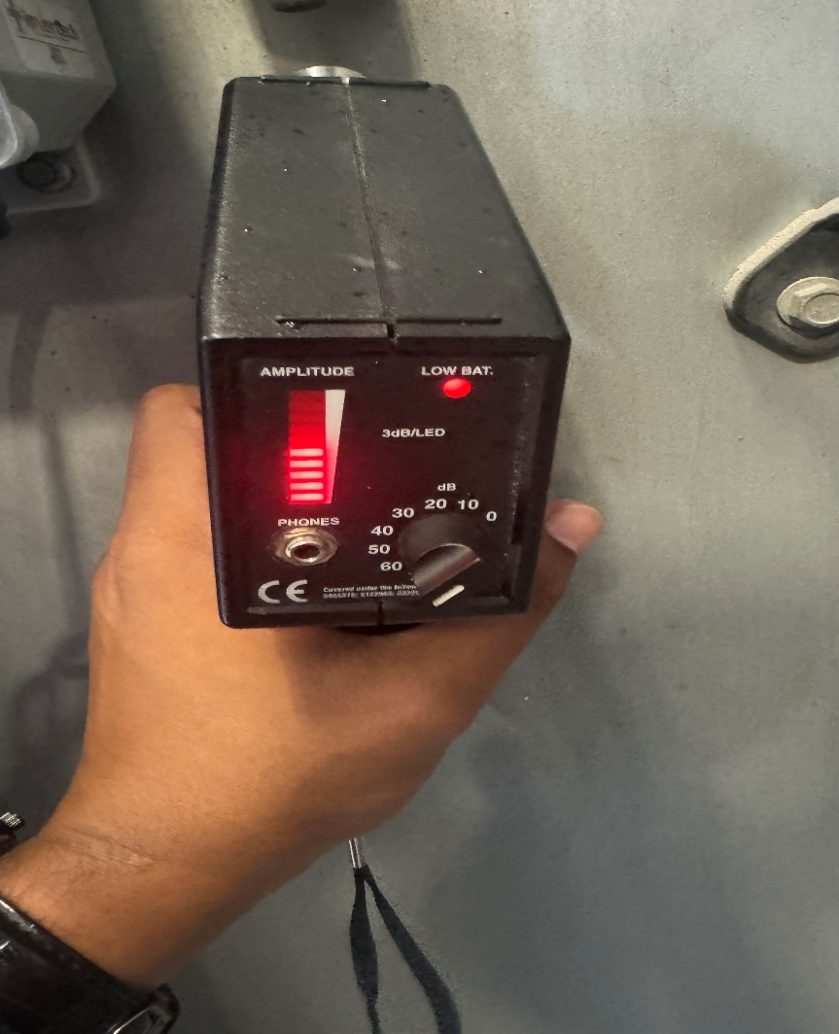
Figure 4-4. Compressed Air Leaks Detected in the Facility.

Recommendation
The maintenance personnel is recommended to implement a preventive maintenance program to check for and repair air leaks continuously. Once implemented, the maintenance program will reduce costs by supplying compressed air to the facility more efficiently in the form of reduced electrical consumption. The related implementation cost per year is associated with the parts and labor required to repair the leaks.
Calculations
During and after the site visit, factors affecting the cost of air leaks were determined and estimated as in Table 4-10.
Table 4-10. The Air Compressor Information
Variable | Air Compressor
Atmospheric Pressure, psia | 14.70
Air Compressor Operation Pressure, psig | 120
Air Compressor Motor Size, HP | 50
Air Compressor Motor Efficiency | 0.941
Air Compressor Type | Rotary screw

From these values, the volumetric flow rate, energy loss, and cost for leaks can be calculated for the conditions at this plant.

Energy Reduction
A sample calculation for the air leak from the air compressor is shown below. First, the volumetric flow rate of free air, V_{f,1}, exiting the leak in the unit of cubic feet per minute (cfm) is calculated. The value (8.05 cfm) is determined from a reference8F and is based upon the leak intensity of 85 dB which was measured on site. The power loss from leaks is estimated as the power required to compress the volume of air lost from atmospheric pressure, Pi, to the compressor discharge pressure, Po, as follows 9F:
L = $\frac{P_{i}×C_{6}×(\sum_{i=1}^{3}{V_{f,i})}×\frac{k}{k-1}×N×C_{7}×\left[{\left(\frac{P_{0}}{P_{i}}\right)}^{\frac{k-1}{k∙N}}-1\right]}{E_{a}∙E_{m}}$
= 1.93 HP,
where
L = Power Loss due to Air Leak, hp
Pi = Inlet (Atmospheric) Pressure, psia = 14.70
C6 = Conversion Constant, 144 in² / ft²
Vf,1 = Volumetric Flow Rate of Leak in the packaging area, cubic feet per minute
= 8.05 cfm
k = Specific Heat Ratio of Air = 1.4
N = Number of Stages = 1
C7 = Conversion Constant, 3.03 x 10⁻⁵ hp-min/ft-lb
Po = Air Compressor Operating Pressure, psia = 120
Ea = Isentropic (Adiabatic) Efficiency for Rotary Type Air Compressor10F = 0.82
Em = Air Compressor Motor Efficiency11F = 0.941

The total energy reduction from fixing these leaks can be calculated as follows:
ER = L $×$ K $×$ PH
= 1.93 HP$×$0.7457 kW/HP $×$ 5,616 hrs/yr
= 8,083 kWh/yr,
where
ER = Energy Reduction, kWh/yr
L = Power Loss due to Observed Air Leaks, HP
K = Conversion Factor, 0.7457 kW/HP
PH = Annual Production Hours = 108 hours/week$×$ 52 weeks /year
= 5,616 hrs/yr

Energy Cost Savings
The energy cost savings due to a reduction in air leaks for the facility is as follows:
ECS = ER $×$ UR
= 8,083 kWh/yr $×$ $ 0.112/kWh
= $905/yr,
where
ECS = Energy Cost Savings, $/yr
ER = Energy Reduction, kWh/yr
UR = Average Electric Usage Rate = $0.112/kWh

Carbon Dioxide Reduction
Due to the reduced electrical usage, there will also be lower carbon dioxide emissions at the electric power generation. These reductions can be calculated as follows:
CO₂ = ER $×$ K₁ $×$ K₂
= 8,083 kWh/yr $×$ 0.763 lb. CO₂/kWh $×$ 1 Ton/2,000lb
= 3 Tons/yr,
where
CO₂ = Amount of Carbon Dioxide Reduced, Tons CO₂/yr
ER = Energy Reduction, kWh/yr
K₁ = Amount of CO₂ Produced per kWh = 0.763, lb CO₂/kWh
K₂ = Conversion Factor = 1 Ton/2,000 lbs

Implementation Cost
LSU-ITAC conservatively estimates that an effective leak reduction program would require one hour of labor at $25/hr per leak. The materials associated with fixing the leaks would be the air
hose repair parts12F,13F,14F, new air hose15F,16F,17F, new valve shut-off switch18F,19F,20F, and leak preventive sealed tape21F,22F,23F depending on leak types. We conservatively assume that the average leak repair cost would be approximately $20 per leak based on the materials required to fix the leak. Thus, overall material costs would be $20 for 1 leak in the facility. The total implementation cost of this recommendation is summed up in Table 4-11. Since it is recommended to have the maintenance personnel conduct the preventive maintenance routinely to check for and repair air leaks, the implementation cost is expected to be a recurring annual cost. In the following payback period calculations, we only considered the implementation cost for the first year.

Table 4-11. The Implementation Cost Summary for AR No. 4
Item | Cost ($)
Labor (One Worker at $25/hr for 1 Leak) | 25
Materials ($20/leak for 1 Leaks) | 20
Total Implementation Cost | 45

Payback Period
PP = IC / TCS
= $45 / ($905/yr)
= 0.05 yrs,
where
PP = Payback Period, yrs
IC = Implementation Cost, $
TCS = Total Cost Savings, $/yr

  - AR No. 5 – Utilize Higher Efficiency Lamps and/or Ballasts
(ARC Code 2.7142)

Table 4-12. The Savings Summary for AR No. 5
Energy Savings (kWh/yr) | Energy Cost Savings  ($/yr) | Demand Savings  (kW/yr) | Demand Cost  ($/yr) | Total Cost Savings ($/yr) | CO₂  Reduction (tons/yr) | Imp. Cost ($) | Payback Period  (yrs)
82,050 | 9,190 | 175 | 593 | 9,783 | 31 | 6,965 | 0.71

Observation and Analysis
During the assessment tour, the team found that the facility used fluorescent lighting fixtures and some LED lights throughout the warehouse on site. Our team observed that there would be potential for cost savings once all fluorescent lighting fixtures are replaced with energy-efficient LEDs. The current lighting fixtures are used during usual shift hours. In total, the number and power ratings of all fluorescent lighting fixtures are summarized in Figure 4-5.

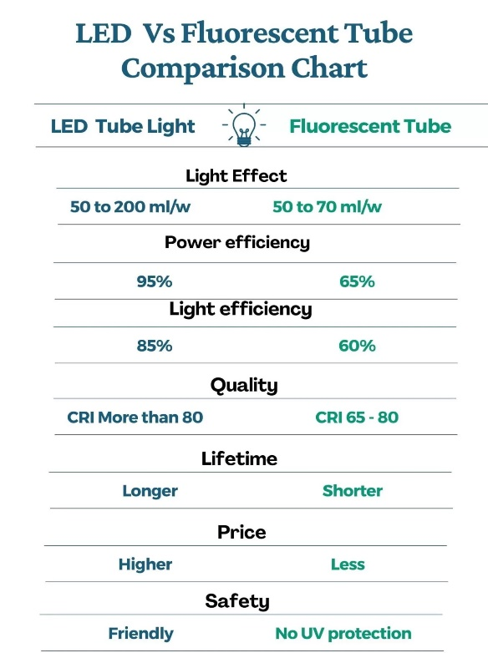
Figure 4-5. The LED vs Fluorescent Lighting comparison.

Table 4-13. The Summary of Existing Lighting Equipment in the Facility
Location | Type | Rated Power (W) | Number Lights | Total Power (W)
Welding Shop | F32T8 | 32 | 245 | 7,840
Computer Machine Shop | F32T8 | 32 | 280 | 8,960
Paint Room | F32T8 | 32 | 340 | 10,880
Inventory Room | F32T8 | 32 | 180 | 5,740
Total Power (W) |  |  |  | 33,420

Recommendation
For the maximum cost and environmental benefits, our team recommends upgrading all the facility’s lighting equipment with LED lights. The advantages of LED lights are that LED lights can work without a ballast, have much lower-rated power, and maintain their initial lumen outputs while lasting longer than fluorescent lights. Additionally, LED lights produce much less heat when in operation. The facility can gradually phase out the current lighting equipment every time a piece burns out and mounts the new LED ones. The facility can switch out the current fluorescent lighting fixtures with the replacement of LED that is rated, as shown in Table 4-14.

Table 4-14. The Summary of Recommended Lighting Equipment in the Facility
Type | Rated Power/ea. (W) | Quantity | Total Power (W)
4ft T8 LED | 18 | 1,045 | 18,810

Calculations
Current Energy Usage
The current fluorescent lights run for the ordinary shift hours. Therefore, current energy consumption for lighting can be estimated as follows:
EU_{C} = W_{F32} × OH× CF
= 33,420 W × 5,616 hrs/yr × 0.001 kW/W
= 187,687 kWh/yr,
where
EU_{C} = Current Annual Energy Usage, kWh/yr
W_{F32} = Collective Wattage of 4ft F32T8 Tubes
OH = Operation Hours for Lights =108 hrs/week ×52weeks/yr = 5,616 hrs/yr
CF = Conversion Factor (kW/W) = 0.001

Proposed Energy Usage
After the facility upgrades all fixtures to LED, the annual electricity usage can be calculated as follows:
EU_{P} = W_{4ftT8} × OH× CF
= 18,810 W × 5,616 hrs/yr × 0.001 kW/W
= 105,637 kWh/yr,
where
EU_{P} = Proposed Annual Energy Usage, kWh/yr
W_{4ftT8} = Collective Wattage of 4ft T8 LED Tubes
OH = Operation Hours for Lights =108 hrs/week ×52weeks/yr = 5,616 hrs/yr
CF = Conversion Factor (kW/W) = 0.001

Electrical Energy Savings
The total amount of electrical energy savings for this implementation can be calculated:
ER = EU_{C} – EU_{P}
= 187,687 kWh/yr – 105,637 kWh/yr
= 82,050 kWh/yr,
where
ER = Electrical Energy Reduction, kWh/yr
EU_{C} = Current Electrical Energy Usage, kWh/yr
EU_{P} = Proposed Electrical Energy Usage, kWh/yr

Electrical Energy Cost Savings
The total electrical energy cost savings with the replacement of all the current lights with LED lights in the facility can be estimated by the following equation:
ECS = ER × UR
= 82,050 kWh/yr × $0.112/kWh
= $9,190/yr,
where
ECS = Total Electrical Energy Cost Savings, $/yr
ER = Electrical Energy Reduced, kWh/yr
UR = Average Electrical Energy Usage Rate = $0.112/kWh

Electrical Demand Savings
The total amount of electrical demand savings can be calculated using the following equation:
EDS = (W_{F32} –W_{T8L}) × CF × 12 months
= (33,420 W – 18,810 W) × 0.001 × 12 months
= 175 kW/yr,
where
EDS = Estimated Demand Savings, kW/yr
W_{T8} = Collective Wattage of 4ft F32T8 Fluorescent Tubes
W_{T8L} = Collective Wattage of 4ft T8 LED Tubes
CF = Conversion Factor (kW/W) = 0.001

Electrical Demand Cost Savings
By lowering the amount of energy, the facility uses during its peak demand period, there will be a lower demand charge. The amount of energy demand cost savings (EDCS) can be estimated using the following equation:
EDCS = EDS × DR
= 175 kW/yr × $3.387/kW
= $593/yr,
where
EDCS = Estimated Demand Cost Savings, $/yr
EDS = Electrical Demand Savings, kW/yr
DR = Demand Charge = $3.387/kW
Total Cost Savings
Since there has been a demand charge on the facility, the total cost savings is the sum of electrical energy cost savings and estimated demand cost savings:
TCS = ECS + EDCS
= $9,190/yr + $593/yr
= $9,783/yr,
where
TCS = Total Cost Savings, $/yr
ECS = Total Electrical Energy Cost Savings, $/yr
EDCS = Estimated Demand Cost Savings, $/yr

Carbon Dioxide Reduction
Due to the reduced electrical usage, there will also be lower carbon dioxide emissions from the electrical power generation. These reductions can be calculated using:
CO₂ = ER × K₁ × K₂
= 82,050 kWh/yr × (0.763 lb CO₂ / kWh) × 1 Ton/2,000lbs
= 31 Tons/yr,
where
CO₂ = Amount of Carbon Dioxide Reduced, Tons/yr
ER = Electrical Energy Reduction, kWh/yr
K₁ = Amount of CO₂ Produced per kWh, 0.763 lb CO₂/kWh
K₂ = Conversion Factor = 1 Ton/2,000 lbs

Implementation Cost
Implementation will involve the labor cost required to replace the lighting fixtures, along with the material cost of the LED lighting equipment. It is assumed that the labor cost is $25/hour, with the time needed for the replacement to be 0.2 hours per fixture for LED tubes. The LED lighting costs, $9/tubes for 4ft F32 replacement.

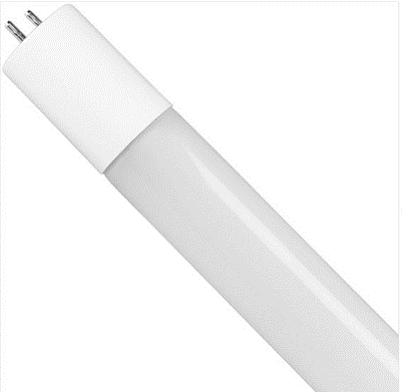
Figure 4-6. Recommended LED Lighting Types

Also, Entergy has a rebate program available in LED lighting fixture retrofit. According to the prescriptive incentive rates requirement, the facility qualifies as a large commercial entity since its monthly peak demand are more than 100 kW. The incentive rate is $4 for every 32W 4ft T8 light replacement. The total implementation cost can be estimated by:
IC = N_{4ftT8} × (UC_{4ftT8} – I_{4ftT8}) + LR × LT × N_{4ftT8}
= 1,045 × ($9/tube – $4/tube) + $25/hour × 0.2 hours/fixture × 348 fixtures = $5,225 (material) + $1,740 (labor)
= $5,225 (material) + $1,740 (labor)
= $6,965
where
IC = Implementation Cost, $
N_{4ftT8} = Number of 4ft T8 LED Tubes Needed
UC_{4ftT8} = Cost per 4ft T8 LED Tube, $/tube
I_{4ftT8} = Incentive Rate for Replacing 4ft T8 Tube, $/tube
LR = Labor Rate, $/hour
LT = Labor Time per 4ftT8 Fixture Replacement, hour/fixture
N_{4ftT8} = Total Number of 4ft T8 Fixtures

The implementation cost is summarized in Table 4-15.

Table 4-15. The Implementation Cost Summary for AR No. 5
Item | Quantity | Unit Cost | Cost ($)
4ft T8 LED Tube,, | 1,045 | $9/tube | 9,405
Incentives | 1,045 | $4/tube | -4,180
Total Material Cost |  |  | 5,225
Labor | (0.2 hours/fixture for 348 fixtures 4ft T8 LED) = 70 hrs. | $25/hr | 1,740
Total Implementation Cost |  |  | 6,965

Payback Period
PP = IC/TCS
= $6,965/ ($9,783/yr)
= 0.71 yrs,
where
PP = Payback Period, yrs
IC = Implementation Cost, $
TCS = Total Cost Savings, $/yr

THE INDUSTRIAL CONTROL SYSTEMS CYBERSECURITY ASSESSMENT
The Industrial Control Systems (ICSs) Cybersecurity Assessment Tool developed by the U.S. Department of Energy can be used to identify cybersecurity risks in small- and medium-sized manufacturing facilities. This assessment tool is based on a questionnaire answered to be answered by the facility's IT personnel during the assessment, as shown in Table ‎5-1. This tool can be used to identify risk areas, provide cybersecurity awareness information, potential solutions, and suggest action items based on the response selected. Due to privacy, this client declined to answer the assessment questions, but we add this tool here for the client's self-assessment later if they decide to.

Table ‎5-1. Industrial Control Systems Cybersecurity Assessment Details
People
1 | Does your plant or facility provide basic cybersecurity awareness training to all employees? | Regular training of employees in proper conduct on company equipment can help prevent accidental downloads of viruses and other system vulnerabilities. Regular training of employees in proper conduct on company equipment can help prevent accidental downloads of viruses and other system vulnerabilities.
1 | Yes
2 | Are staff assigned and trained to take appropriate measures during a cybersecurity incident? | Having employees who are trained to respond to cybersecurity threats in a timely way is important to  mitigate the damage and cost associated with a cyberattack. Employees do not necessarily need to be well versed in cybersecurity, but should be trained to quickly and safely shut off equipment and to contact a vendor, consultant, or other expert who is capable of a cybersecurity review of the asset.
2 | Yes
3 | Do your industrial control system (ICS) vendors provide remote support? | Since vendors do not have remote access to plant systems, risk of unauthorized access to industrial controls systems is minimized.
3 | No, there are no vendors who assist us remotely with our ICS or other plant equipment
4 | What level of on-site physical security does your facility or plant enforce upon vendors? | Vendors may unknowingly bring malware or cause intrusions in systems in which they work. As a result, confining vendors to a single portion of the facility/plant results in a decreased likelihood that they will connect their hardware or software to unauthorized plant systems.
4 | Vendors are allowed restricted physical access and may only work under supervision within a designated area
5 | Do third party vendors have proper cybersecurity training? | Ensuring vendors have a proper understanding of cybersecurity best practices helps avoid accidental contamination of on-site systems. Ensuring vendors have a proper understanding of cybersecurity best practices helps avoid accidental  contamination of on-site systems.
5 | Yes
6 | Do vendors utilize their own equipment, hardware, or software during site visits? | By restricting the equipment brought in by vendors, you are preventing the potential for vendor hardware and software to transmit viruses or malware to facility/plant systems. By restricting the equipment brought in by vendors, you are preventing the potential for vendor  hardware and software to transmit viruses or malware to facility/plant systems.
6 | No, vendors do not bring hardware and are able to troubleshoot using our in-house tools and equipment
Process
7 | Have you identified critical equipment in your plant or facility that would cause disruption to your operations if they were compromised? | Your critical equipment, data, or software are the systems that, if inoperable, would shut down your entire plant. Being able to identify these systems will decrease risk of disruption.
7 | Yes
8 | Does a plan exist to identify and isolate impacted assets, or shut down equipment as necessary in the event of a cybersecurity incident? | This plan should be updated periodically to reflect changing plant conditions and systems.
8 | Yes
9 | Does your plant or facility have a cybersecurity incident response procedure? | A cybersecurity incident response procedure helps ensure that a team has the appropriate resources and recognizes critical actions necessary to respond to various incidents, including severe weather and cyberattacks, should they occur.
9 | Yes
10 | Does a central repository containing equipment schematics, IT infrastructure drawings, and system network layouts exist within the facility? | Equipment and IT schematics as well as data backups will help in the event of an emergency shutdown. If vendors need to access and clean the system, they will need to be thorough and check all  system components. Keep this repository current as you add new production lines or update machinery. Equipment and IT schematics as well as data backups will help in the event of an emergency  shutdown. If vendors need to access and clean the system, they will need to be thorough and check all system components. Keep this repository current as you add new production lines or update machinery.
10 | Yes
11 | Is cybersecurity considered when purchasing supplies or equipment, and is it defined in your contractual obligations with vendors? | By including cybersecurity in your vendor contracts, you have established expectations and a liability framework. By including cybersecurity in your vendor contracts, you have established expectations and a liability framework.
11 | Yes
12 | Does plant/facility equipment get regularly or automatically scanned for cybersecurity issues (e.g., malware, etc.)? | By performing scans regularly, a plant or facility can ensure the integrity of all systems and avoid security risks. The automatic scheduling of security scans could help ensure that scans are not missed due to human error.
12 | Yes, equipment is regularly scanned Yes, equipment is regularly scanned
13 | Is the use of external media by staff and vendors regulated within the plant/facility and scanned for cybersecurity issues? | Allowing external media, such as USB drives, in the facility can lead to the introduction of malware and unsecured programs. Allowing external media, such as USB drives, in the facility can lead to the introduction of malware and Sunsecured programs.
13 | Yes, USBs or similar external media are not allowed within the facility
Technology
14 | Which of the following best describes the industrial controls in your plant or facility? | Although portions of the industrial process may individually be at risk to cyber incidents, different ICS environments are somewhat insulated from one another, which can slow or contain viruses. Although portions of the industrial process may individually be at risk to cyber incidents, different ICS environments are somewhat insulated from one another, which can slow or contain viruses.
14 | Automated facility with multiple ICSs to control various stages of manufacturing Automated facility with multiple ICSs to control various stages of manufacturing
15 | Are indicators or alerts set up on critical equipment to indicate unusual changes to operating parameters, multiple login attempts, or detect other anomalies in use? | These alarms will notify you if unauthorized users are changing equipment operating parameters or may be close to damaging equipment.
15 | Yes
16 | Does the plant or facility have any equipment that is programmable or reconfigurable by remote staff? | Not allowing remote access helps eliminate risk from remote employees who may have malware-contaminated hardware they use for system access. Not allowing remote access helps eliminate risk from remote employees who may have malware-contaminated hardware they use for system access.
16 | No
17 | Does your industrial control system (ICS) allow remote access? | Not allowing remote access helps eliminate risk from remote employees who may have malware-contaminated hardware they use for system access.
17 | No
18 | Are there processes in your plant with operating parameters that are interdependent with other processes? | While it can improve operations, allowing systems to function based on upstream data can create risk. If a bad actor were to modify data to cause the system to malfunction, equipment damage or loss of production could result. To minimize risk, upstream data can be secured and traffic on your ICS can be monitored via firewalls, and alarms can be used to alert the plan to any abnormal operation. While it can improve operations, allowing systems to function based on upstream data can create risk. If a bad actor were to modify data to cause the system to malfunction, equipment damage or loss of  production could result. To minimize risk, upstream data can be secured and traffic on your ICS can be  monitored via firewalls, and alarms can be used to alert the plan to any abnormal operation.
18 | Yes
19 | How are modifications to parameters or set-points made within your manufacturing process? | Specialized ICS software is generally not a foolproof way to protect the integrity of your industrial processes. However, there are fewer malware products and individuals capable of infiltrating ICS  software than common operating systems, like Windows.
19 | A standard PC running dedicated control system software (does not necessarily look like Windows)
20 | Do the computers that run your industrial control system (ICS) allow employees or vendors to import files from external media? | When external files are introduced to the ICS environment they could potentially introduce malware or other contaminants.
20 | No
Overall Risk: -

https://www.entergy.com/userfiles/content/environment/docs/EntergyClimateScenarioAnalysis.pdf
https://www.eia.gov/environment/emissions/co2_vol_mass.php
https://www.ashrae.org/file%20library/technical%20resources/standards%20and%20guidelines/standards%20addenda/90_1_2007_supplement.pdf
https://www.energystar.gov/sites/default/files/asset/document/HeatingCoolingGuide%20FINAL_9-4-09_0.pdf
https://www.energystar.gov/sites/default/files/asset/document/ES_Duct_Sealing_flyer.pdf
https://www.energystar.gov/campaign/heating_cooling/maintenance_checklist
https://cdn.entergy-neworleans.com/userfiles/content/energy_smart/New_Orleans_TRM/New_Orleans_TRM_Version_4.pdf?_ga=2.133563150.1668419602.1612231118-1396779669.1607644065#page=330&zoom=100,92,610
https://www.aceee.org/files/proceedings/2016/data/papers/1_1168.pdf
https://cdn.entergy-louisiana.com/userfiles/content/energy_efficiency/docs/Commercial-CI-Incentives.pdf?_gl=1*8xwtm1*_gcl_au*MTIyMzU2MDE2OC4xNjk2NDM5MTc0*_ga*MTE3MTYxNDUyNy4xNjk2NDM5MTc0*_ga_2KJW590NWN*MTY5NjQzOTE3My4xLjEuMTY5NjQzOTE4Ni40Ny4wLjA.*_ga_H0JW6TJK3Y*MTY5NjQzOTE3My4xLjEuMTY5NjQzOTE4Ni4wLjAuMA..*_ga_8YKL3FLBBC*MTY5NjQzOTE3My4xLjEuMTY5NjQzOTE4Ni40Ny4wLjA.&_ga=2.153685048.1625396085.1696439174-1171614527.1696439174
https://www.compressedairchallenge.org/data/sites/1/media/library/sourcebook/Improving_Compressed_Air-Sourcebook.pdf
https://www.energy.gov/sites/prod/files/2014/04/f15/amo_motors_handbook_web.pdf
https://www.compressedairchallenge.org/data/sites/1/media/library/sourcebook/Improving_Compressed_Air-Sourcebook.pdf
https://cdn.entergy-louisiana.com/userfiles/content/energy_efficiency/docs/Commercial-CI-Incentives.pdf?_gl=1*xcemaa*_gcl_au*NDgyMjg0NDUwLjE2ODA0NjAyMjA.*_ga*MTE5ODQyOTk4NS4xNjgwNDYwMjIw*_ga_2KJW590NWN*MTY4NzQ1OTcxMC4zLjEuMTY4NzQ1OTk0Ny4wLjAuMA..*_ga_8YKL3FLBBC*MTY4NzQ1OTcxMC4zLjEuMTY4NzQ1OTk0Ny4wLjAuMA..&_ga=2.173080549.775869360.1687459710-1198429985.1680460220
https://www.prolighting.com/swx-511-he.html?utm_source=google_shopping&pl=&gclid=CjwKCAiA4KaRBhBdEiwAZi1zztKIr3ZUjtGkseVli2nBdfgqBTZ5Pa0eaze6cJLgBQhb-hsSzdP2nxoCZ8sQAvD_BwE
https://www.commercialbulbs.com/item/0232629/lithonia-cmrb-6-p-fixture-mount-line-voltage-high-mount-360deg?gclid=CjwKCAiAyp-sBhBSEiwAWWzTnpQgdY1Sg5d8jTMjim17VMq0gm0cI9MO7fiVlrkHF8gsmxCpZydpoBoCDr8QAvD_BwE
https://www.leviton.com/en/products/osfhp-i4w
https://www.warehouse-lighting.com/products/pir-high-bay-360-line-voltage-occupancy-sensor-120-277v
https://www.build.com/product/summary/888728?uid=2250876&jmtest=gg-gbav2_2250876&inv=1&&source=gg-gba-pla_2250876!c1711171888!a69713256474!dc!ng&gclid=CjwKCAiA4KaRBhBdEiwAZi1zzu9lRkGaw5k6TA-_ev-VkUAnUqFUTffV5KMjbG1_VVmeBjsQo9FXRBoCSJsQAvD_BwE&gclsrc=aw.ds
https://www.prolighting.com/swx-511-he.html?utm_source=google_shopping&pl=&gclid=CjwKCAiA4KaRBhBdEiwAZi1zztKIr3ZUjtGkseVli2nBdfgqBTZ5Pa0eaze6cJLgBQhb-hsSzdP2nxoCZ8sQAvD_BwE
http://info.ornl.gov/sites/publications/files/Pub71598.pdf
Rollins, J.P. ed., Compressed Air and Gas Handbook, 5th Edition, Compressed Air and Gas Institute, New Jersey, 1989, Chapters 10 and 11.
Anthony Barber, Pneumatic Handbook, 7th ed., Trade and Technical Press, 1989, p. 49.
https://www.energy.gov/sites/prod/files/2014/04/f15/amo_motors_handbook_web.pdf
https://www.homedepot.com/p/BLUBIRD-Fast-Fix-3-8-in-Air-Hose-Assembly-Repair-Fitting-BLBFFFX38/307776765
https://www.forneyind.com/products/flex-hose-repair-fitting-1-4-x-1-4-mpt
https://www.pscpartsstore.com/34/1777024
https://www.harborfreight.com/14-in-x-25-ft-polyurethane-air-hose-64027.html
https://www.lowes.com/pd/Primefit-1-4-in-50-ft-Polyurethane-Air-Hose/1000777048
https://www.acehardware.com/departments/tools/air-compressors-and-tools/air-hoses/1795673
https://www.grainger.com/product/1CKD1?gucid=N:N:PS:Paid:GGL:CSM-2295:4P7A1P:20501231&gad_source=1&gclid=CjwKCAiAzc2tBhA6EiwArv-i6f9FohZAF3pGzz2qUNmnnelswNMG7hCKg1lmEYI_i2OrXDRTG5YoEBoCwh8QAvD_BwE&gclsrc=aw.ds
https://www.mcmaster.com/4628K81/
https://www.zoro.com/zoro-select-14-fnpt-brass-ball-valve-inline-g-adv-25/i/G0352129/?utm_source=google&utm_medium=surfaces&utm_campaign=shopping%20feed&utm_content=free%20google%20shopping%20clicks&campaignid=19717005309&productid=G0352129&v=&gad_source=1&gclid=CjwKCAiAzc2tBhA6EiwArv-i6Rl_h7E6YexFs6j4NlXz1coNETipyijMs_vhUQrvQCQrqEBOux35VRoCYH4QAvD_BwE&gclsrc=aw.ds
https://www.staples.com/Plastomer-Premium-Grade-High-Density-Thread-Sealant-Tape-520-in-L-1-2-in-W/product_858494
https://www.bestmaterials.com/detail.aspx?ID=24548
https://www.uline.com/Product/Detail/S-14666/Thread-Sealing-Tape/Thread-Sealing-Tape-1-2-x-520?pricode=WB1988&gadtype=pla&id=S-14666&gad_source=1&gclid=CjwKCAiAzc2tBhA6EiwArv-i6ZvOZbJtmBP_VPcer_DImK5lsS2vwQ16tPOkluxsRO1u1eRKR7N5TxoCTRQQAvD_BwE
https://www.youtube.com/watch?v=Zjw2UXVJaS0
https://cdn.entergy-louisiana.com/userfiles/content/energy_efficiency/docs/Commercial-CI-Incentives.pdf?_gl=1*1mkb2of*_ga*ODEzMDkyMTEwLjE2NzQ5MjgxNTE.*_ga_8YKL3FLBBC*MTY3NTYwNzE0OC42LjEuMTY3NTYwODQ4OC4wLjAuMA..*_ga_HK6YSZ6LT0*MTY3NTYwNzE0OC42LjEuMTY3NTYwODQ4OC4wLjAuMA..*_ga_2KJW590NWN*MTY3NTYwNzE0OC42LjEuMTY3NTYwODQ4OC4wLjAuMA..&_ga=2.69482192.1311610344.1675607149-813092110.1674928151
https://www.bulbs.com/product/CLT97-18WAB3-40K?cm_mmc=GooglePLA-_-Nonbrand-_-17940630953-_-shopping&affID=6&gad=1&gclid=Cj0KCQiAgK2qBhCHARIsAGACuzl7IaqNcE-bfYZiU2fm4PgBZ8MZd-VJrATaY4iJkkdlpmivIj7ESPEaAmWKEALw_wcB
https://www.1000bulbs.com/product/224745/HALCO-84887TC.html?gclid=Cj0KCQiAgK2qBhCHARIsAGACuznIb-YbmTwUr2YrdOQV-r2ifFIcsMp6dOekRaNcEUXqSDT63eqmrwIaAgDvEALw_wcB
https://www.lightup.com/case-of-25-t8-led-4ft-tube-18-watt-direct-wire.html?sku=LEDTB4F1000050873-5000K&gclid=Cj0KCQiAgK2qBhCHARIsAGACuzlBcLwPyeJK9Bks_aczhtmjgOCxOG9NqaFKin0O_DS9IBiy1QF5jdwaAvzNEALw_wcB
https://cdn.entergy-louisiana.com/userfiles/content/energy_efficiency/docs/Commercial-CI-Incentives.pdf?_gl=1*1mkb2of*_ga*ODEzMDkyMTEwLjE2NzQ5MjgxNTE.*_ga_8YKL3FLBBC*MTY3NTYwNzE0OC42LjEuMTY3NTYwODQ4OC4wLjAuMA..*_ga_HK6YSZ6LT0*MTY3NTYwNzE0OC42LjEuMTY3NTYwODQ4OC4wLjAuMA..*_ga_2KJW590NWN*MTY3NTYwNzE0OC42LjEuMTY3NTYwODQ4OC4wLjAuMA..&_ga=2.69482192.1311610344.1675607149-813092110.1674928151

